# React Lab Report - ScoreCalculatorApp

## Introduction

In this lab, I explored the use of React function components by building a simple Student Management Portal named 'scorecalculatorapp'. The focus was on creating and styling a functional component that accepts input properties and displays computed results.

## Objectives and What I Learned

* Objectives:
* Explain React components
* Identify the differences between components and JavaScript functions
* Identify the types of components
* Explain class component
* Explain function component
* Define component constructor
* Define render() function
* What I Learned:
* React components are the building blocks of UI that manage state and render UI elements.
* Components differ from regular JavaScript functions as they return JSX and can manage their own lifecycle.
* There are class and function components in React.
* Class components use ES6 class syntax and include a render() method.
* Function components are simpler and use hooks like useState for state management.
* The constructor is used to initialize state in class components.
* The render() function is specific to class components and returns JSX to render.

## Hands-on Practice Summary

I created a React project named 'scorecalculatorapp' using create-react-app. Inside the project, a folder named 'Components' was created containing the 'CalculateScore.js' function component. This component accepts props such as Name, School, Total, and Goal, calculates the average score, and displays the result. A stylesheet was added for styling, and the component was rendered in App.js.

## Code Snippets

### App.js

import './App.css';  
import CalculateScore from './Components/CalculateScore';  
  
function App() {  
 return (  
 <div className="App">  
 <CalculateScore Name="John Doe" School="ABC High School" Total={450} Goal={500} />  
 </div>  
 );  
}  
  
export default App;

### CalculateScore.js

import React from 'react';  
import '../Stylesheets/mystyle.css';  
  
function CalculateScore(props) {  
 const average = (props.Total / props.Goal) * 100;  
  
 return (  
 <div className="score-box">  
 <h2>Student Score Calculator</h2>  
 <p><strong>Name:</strong> {props.Name}</p>  
 <p><strong>School:</strong> {props.School}</p>  
 <p><strong>Total Marks:</strong> {props.Total}</p>  
 <p><strong>Goal:</strong> {props.Goal}</p>  
 <p><strong>Average Score:</strong> {average.toFixed(2)}%</p>  
 </div>  
 );  
}  
  
export default CalculateScore;

### mystyle.css

.score-box {  
 border: 2px solid #4CAF50;  
 padding: 20px;  
 margin: 20px;  
 border-radius: 10px;  
 background-color: #f9f9f9;  
 font-family: Arial, sans-serif;  
}

## Screenshot

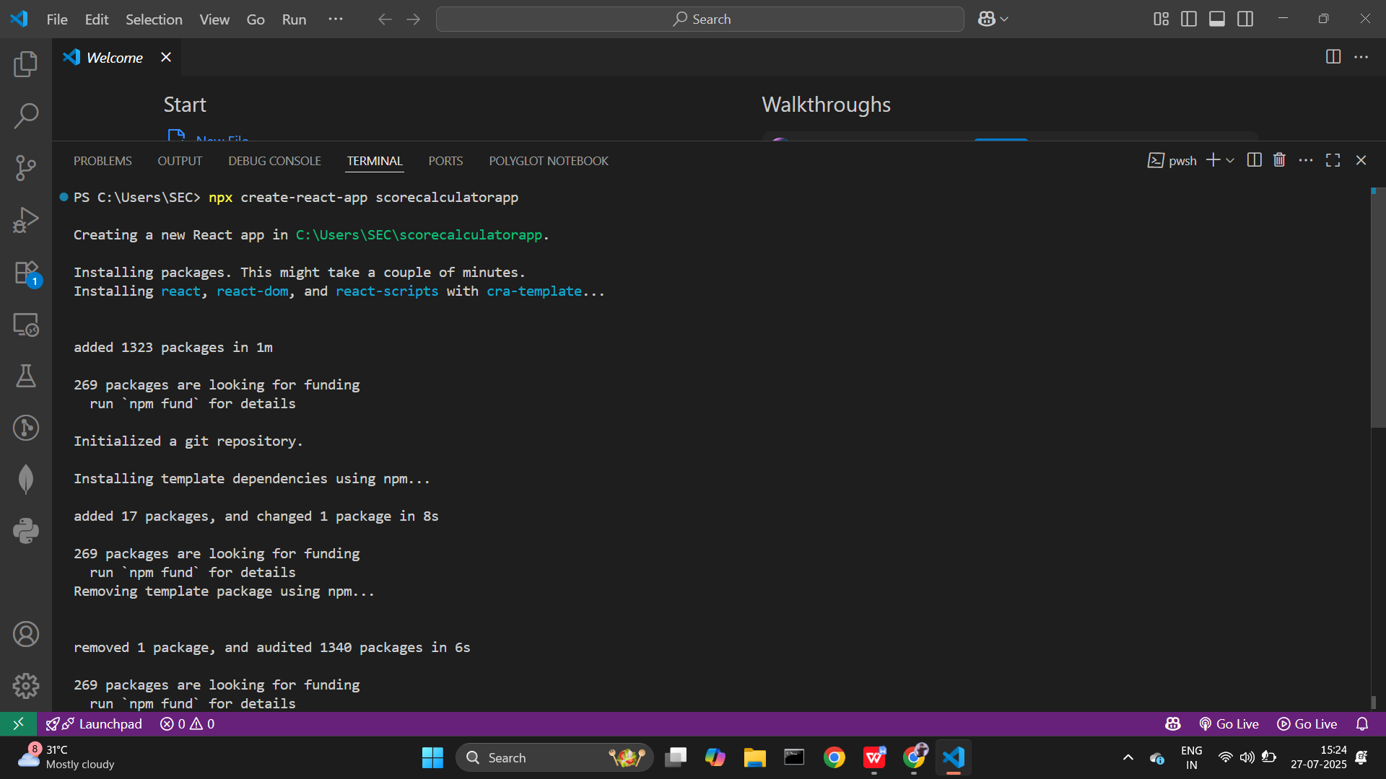

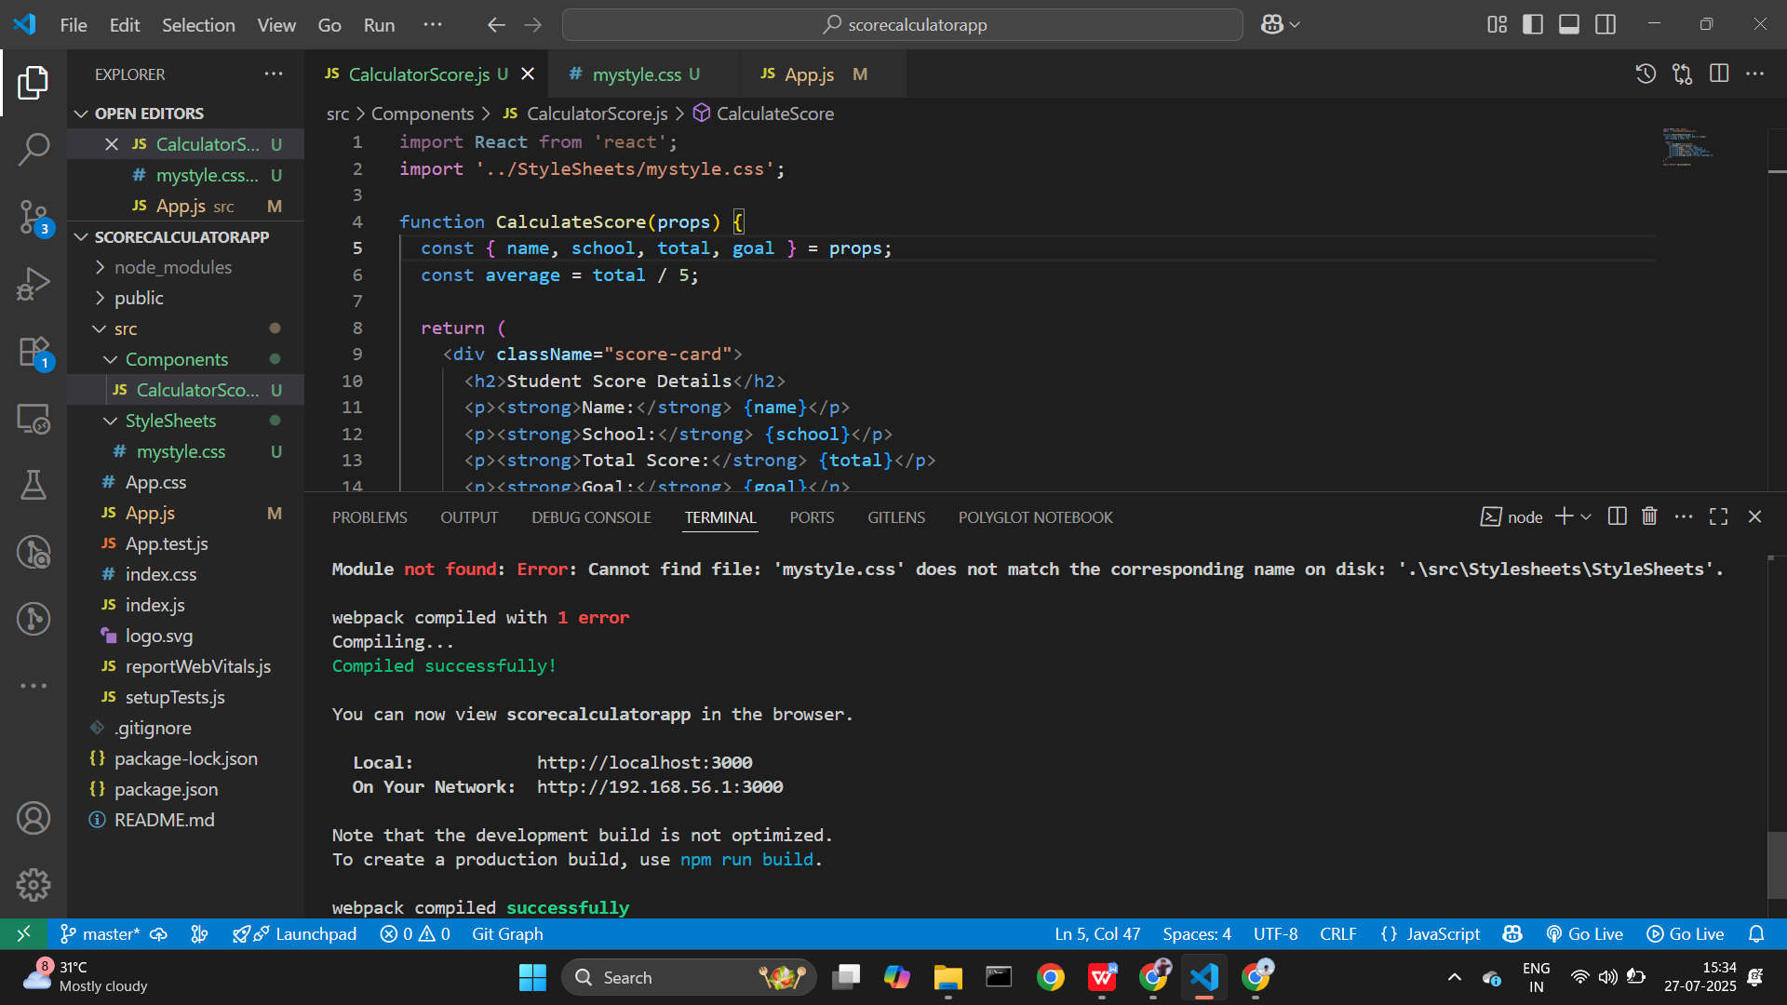

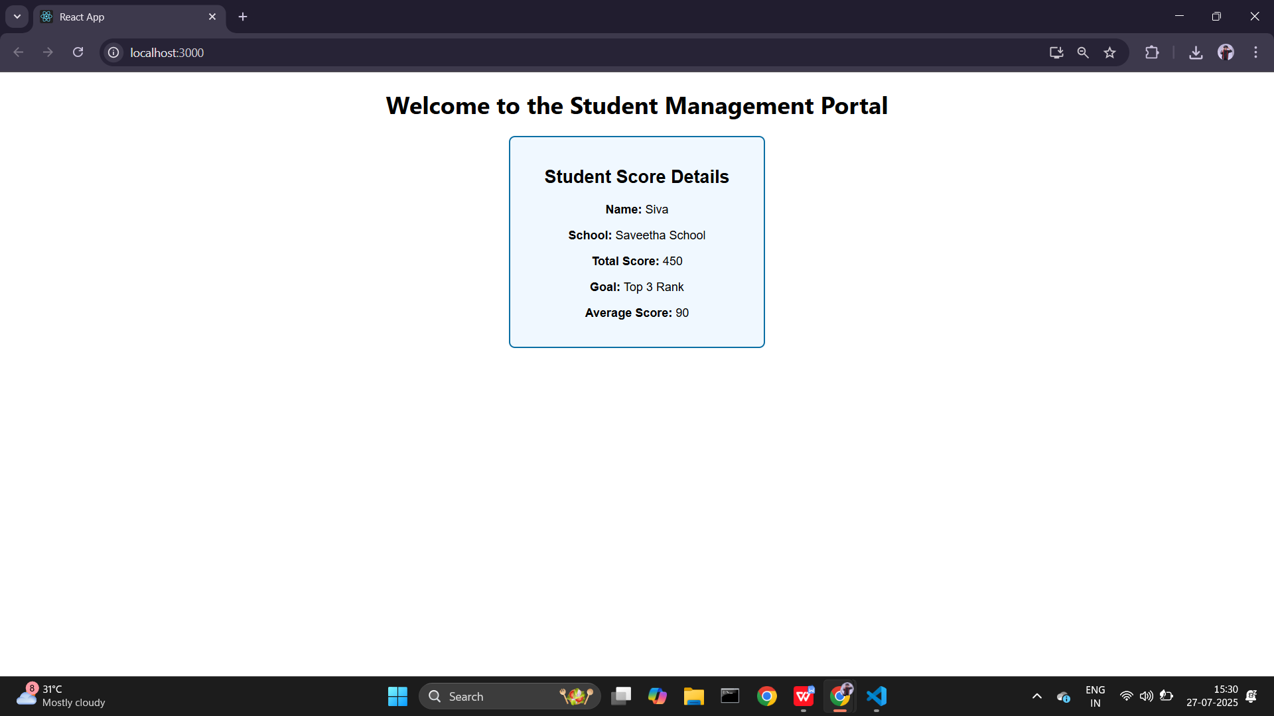

## Conclusion

This lab helped me understand how function components work in React. I learned how to pass props, compute values dynamically, apply styles, and render the components in the browser. It was a valuable exercise in building a small but functional React application.